Working With CSS And HTML Activity

#### **Learning Outcome Addressed**

 1. Apply styles to HTML code

Follow the instructions in NextTech to complete the activity.

Top of Form

This tool needs to be loaded in a new browser window

Load Working With CSS And HTML Activity (60:00) in a new window

Bottom of Form

### Adding Style To Web Pages

Now that you have some familiarity with CSS, you are going to get hands-on experience styling a web page.

Your task in this activity is to apply the following style requirements to the elements in the HTML page index.html:

* Change the text color for all h1 HTML tags to #0170FF
* Change the text color for all a HTML tags to #FF0101
* Implement the class content. This class should have the following style rules:
  + Padding should be 20px
  + Margin should be 10px
  + Text should be italic.
  + The background color should be #424EDC
  + The text color should be #ffffff
* Update the ul and li styles to match the following design:

[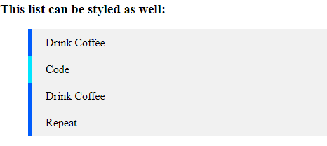](https://cdn.filestackcontent.com/5rBp11XTsaxiTGJCbx9I)

* Implement the footer CSS class. This class should have the following style rules:
  + The text should be centered
  + Padding should be 20px
  + Margin should be 10px
  + The background color should be #424EDC
  + The text color should be #ffffff

The style rules should be defined in the file styles.css and this file should be imported into the index.html file.

Task

* Follow instructions to add CSS styles to the index.html page.